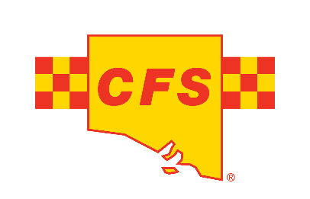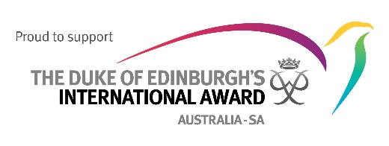 

Monday, November 18, 2024

**South Australian young people graduate from inaugural Youth in Emergencies Development Program, Building Key Skills for Disaster Preparedness.**

With emergencies increasing in frequency and severity, South Australian students have taken a significant step toward disaster preparedness, as they graduated from the Youth in Emergencies Development Program (YEDP). This two-year program, delivered by Australian Red Cross in partnership with the South Australian Country Fire Service (SACFS), Commissioner for Children and Young People Helen Connolly, and supported by The Duke of Edinburgh’s International Award, has equipped these young graduates with critical skills to respond confidently to emergencies and contribute to community resilience.

Open to Year 9-12 students across South Australia, YEDP provides a mix of self-paced learning, interactive workshops, and hands-on experience through a community resilience project. During 2023, the program was co-designed by young people, for young people, and has been implemented throughout 2024.

“Children and young people often face greater impacts in emergencies but are underrepresented in emergency planning. Programs like YEDP empower them with essential skills to handle disasters and build resilience,” said Helen Connolly, Commissioner for Children and Young People SA.

Graduates received the Duke of Ed Bronze Award which provides them with 10 SACE points towards their schooling. They celebrated their achievement by showcasing the outcomes of their community emergency preparedness projects to emergency management leaders. The ceremony included the presentation of certificates by Peter Kaye, CEO of the Duke of Edinburgh’s Award, following the students’ completion of an overnight “Adventurous Journey” that built their practical skills, teamwork, and leadership abilities.

“Australian Red Cross is proud to be helping young people become agents of change, by engaging them as active participants and potential leaders in their communities, demonstrating the powerful role young people can play in disaster management. By fostering their skills and confidence, YEDP supports their meaningful inclusion in South Australia’s emergency preparedness efforts”, said Sarah Strathearn, Australian Red Cross State Director.

This pilot project was funded under the Disaster Risk Reduction Grants Program, by the Australian Government and the South Australian Government.

Media enquires: 1800 733 443, [media@redcross.org.au](mailto:media@redcross.org.au)